File Manager
Design Document

The file Manager should approximately look as follows:
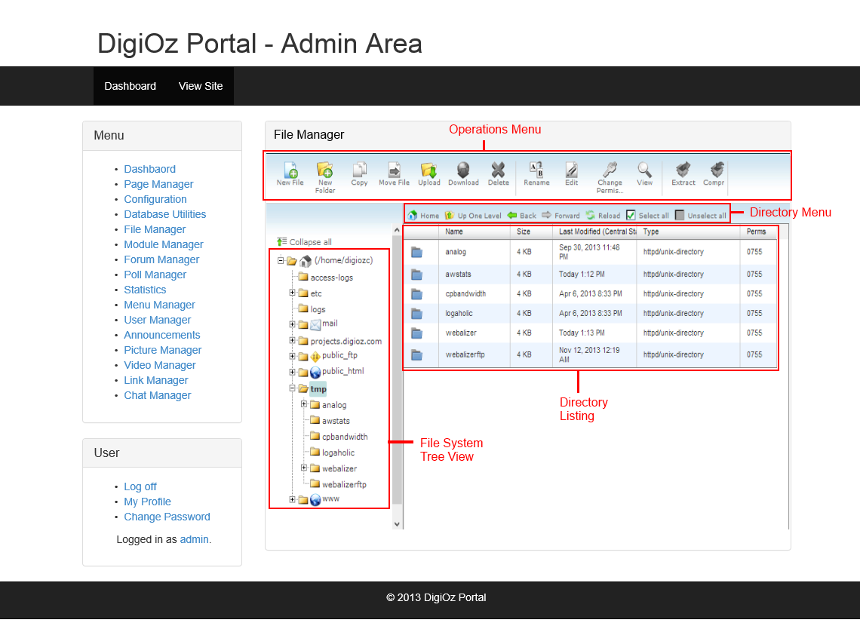

Note that the overall looks of the File Manager box does not have to exactly match the above Mockup, but the features should be identical to what is outlined above.

Operations Menu
The Operations Menu will perform an Operation on the files or folders selected in the Directory Listing. This Menu will have the following options:
- New File
- New Folder
- Copy
- Move File
- Upload
- Download
- Delete
- Rename
- Edit
- Change Permission
- View
- Extract
- Compress
File System Tree View
Here is an overview of how the tree view should work:
- The File System Tree View will allow the webmaster to drill down on the folders, starting with the web root folder and working its way inside.
- The Admin should be able to expand each folder to see other sub-folders inside of the folder they selected.
- Each time a new folder is selected, the contents of that folder (both files and folders inside of it) are shown in the Directory Listing Area
- The Admin should be able to select a folder or file inside the Directory Listing Area, and perform one of the operations outlined in the “Operations Menu” area on the selection they have made.

